Assignment – 4

|  |  |
| --- | --- |
| Student Name | Harshini B |
| Student Roll Number | 211419104098 |
| Maximum Marks | 2 Marks |

# Question 1:

Pull an image from docker hub and run it in docker playground.

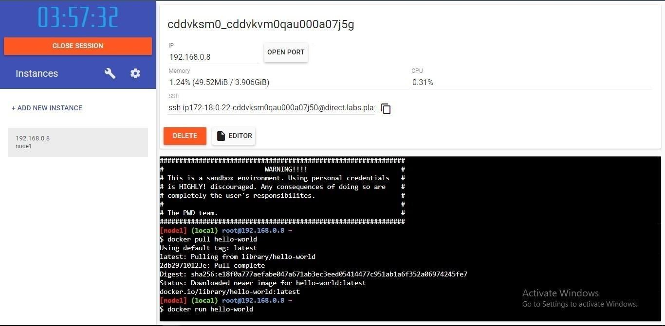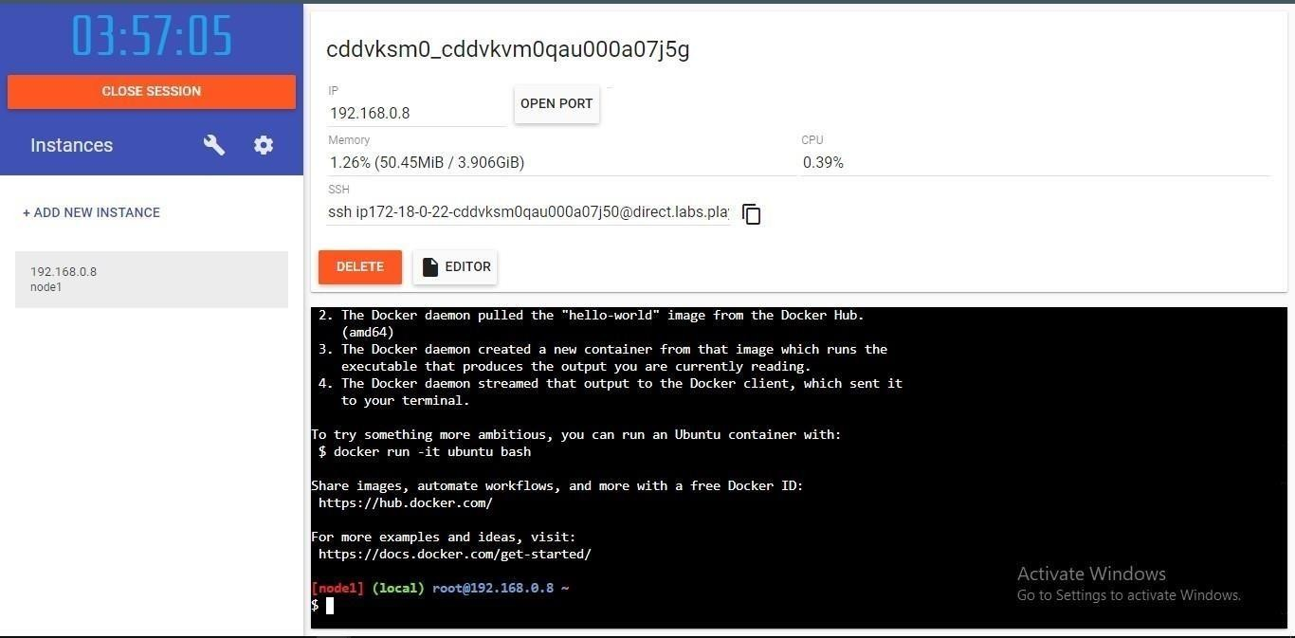

# Question 2:

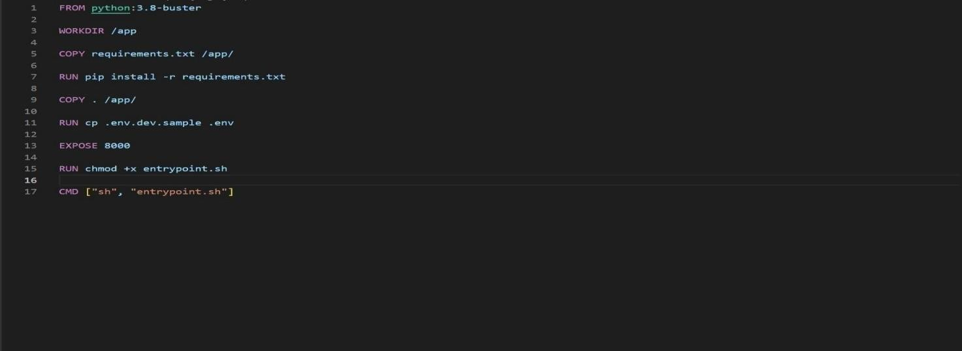Create a docker file for the job portal application and deploy it in Docker desktopapplication. DOCKER FILE:

DEPLOYMENT OF JOBPORTAL APPLICATION:

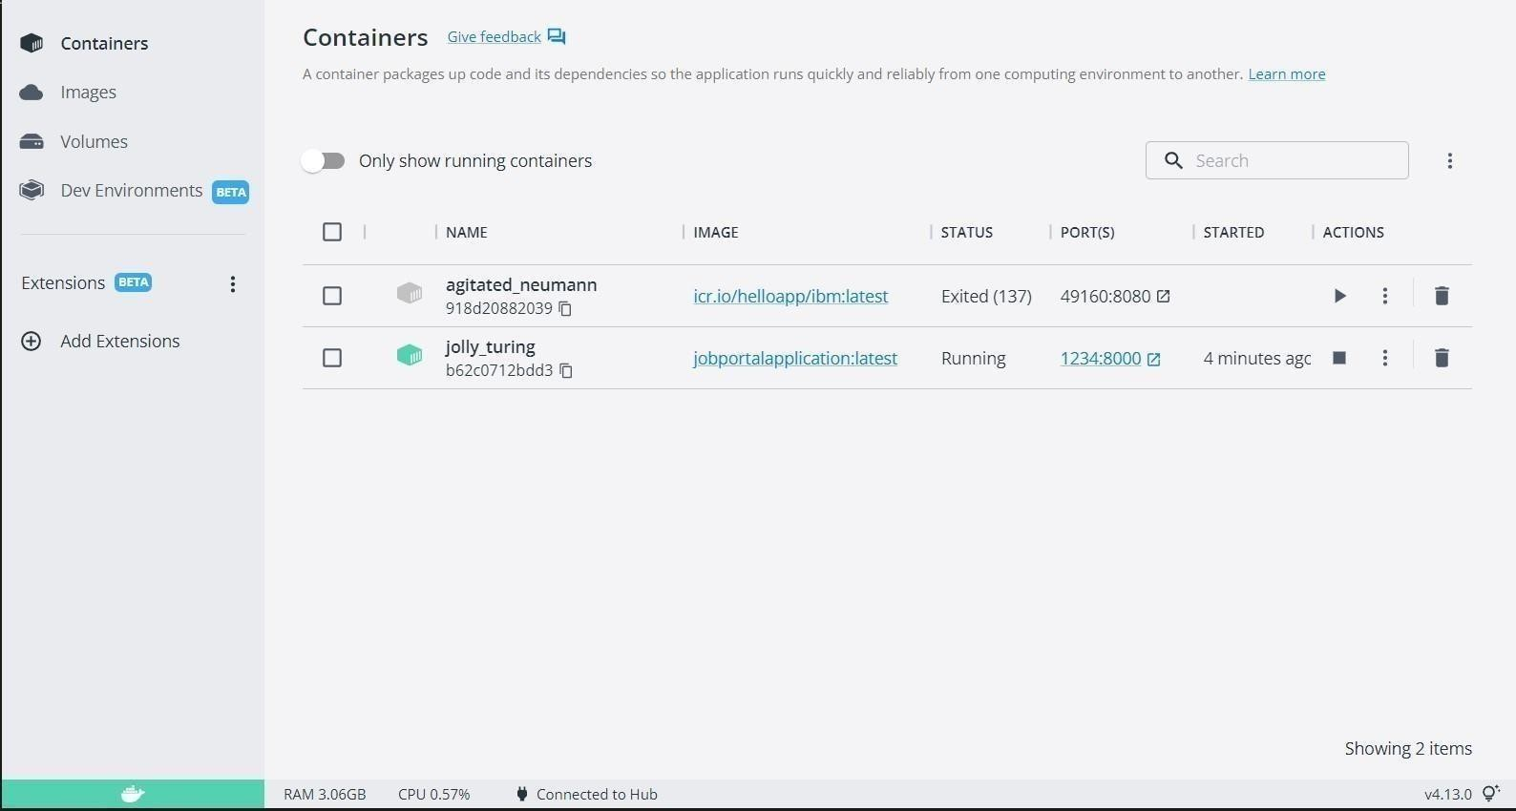

# OUTPUT:

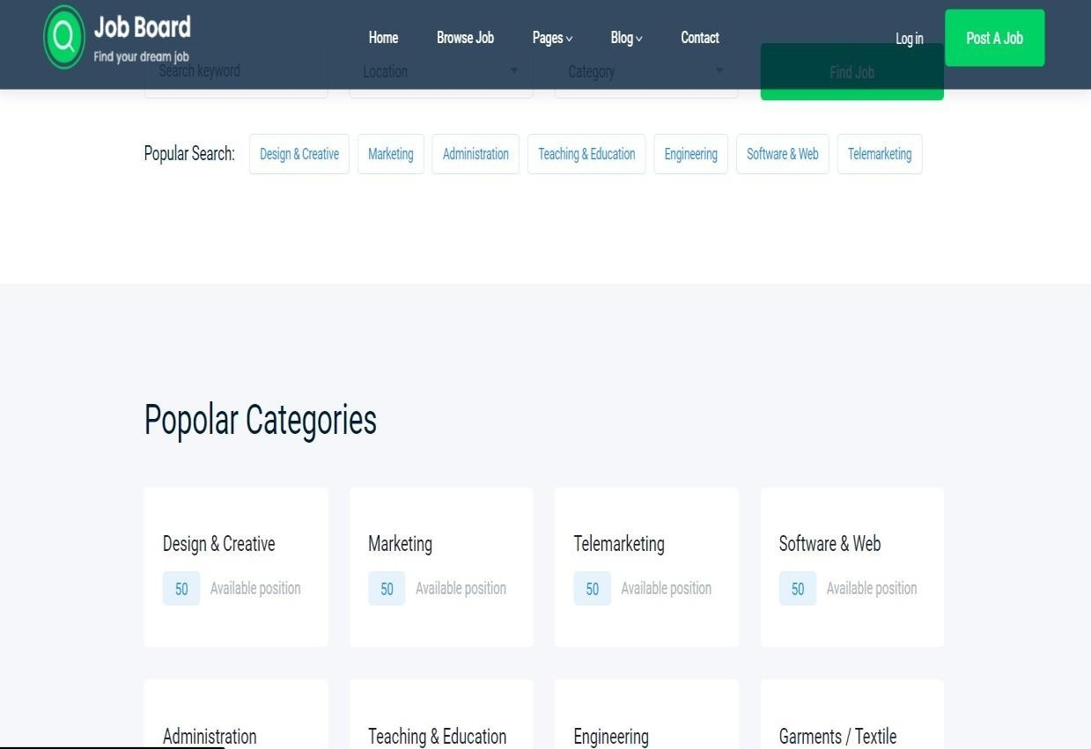

**Question 3:**

Create a IBM container registry and deploy hello-world app or job port app.IBM CONTAINER REGISTRY DEPLOYMENT:

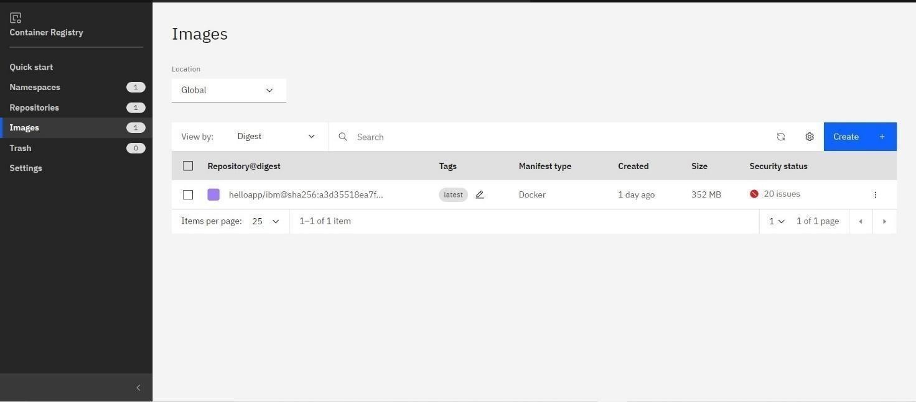

# OUTPUT:



**Question 4:**

Create a Kubernetes cluster in IBM cloud and deploy hello world image or job portal image andalsoexposethe same app to run in node port.

Creating Kubernetes cluster in IBM cloud and exposing node port:

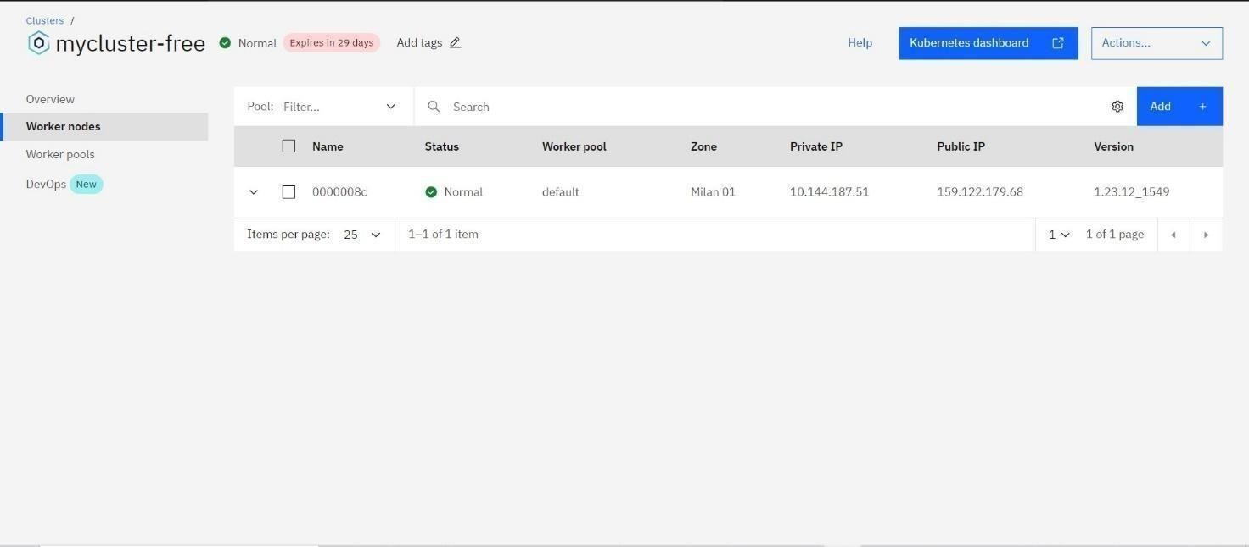

# Output:

